Architecture
The agent is built as two separate processes separating the controller from the evaluator so the model’s actions don’t see the answer key. The trusted controller on the host loads each challenge through NYU CTF, holds the expected flag, enforces resource caps and pacing, manages the challenge lifecycle, verifies the submitted flag from the solver privately, and writes the record and trace from each challenge. The solver is a completely isolated tool‑capable model (Haiku 5.5; initial pilots used GPT 4.1 mini) served through the Duke AI Gateway. It proposes one action at a time, reviews the result, reasons, and then repeats. Its tools execute inside a locked‑down sandbox and the solver never receives the flag, any secrets, or the challenge metadata. The controller follows an observe then act loop. It resets the solver and target and then continues to ask the model for its next action, runs that action, feeds the result back to the model, and continues this cycle until the flag is verified or a budget limit is reached (or an error occurs)
The solver’s tools run inside a Docker sandbox created from a fixed image that automatically deletes the container after an attempt ends. The container runs as an unprivileged user with all Linux capabilities stripped (--cap-drop ALL) and no new privileges allowed (--security-opt no-new-privileges). The root filesystem is set as read-only and only a small writable temporary workspace is allowed with memory, CPU, and process limits. Only the given challenge’s files are mounted in the workspace so nothing else is exposed. Finally, the sandbox has no route to the internet or host, so the solver can reach nothing except the challenge target. Doing so enforces the requirements to avoid answer lookups and other cheating at the network layer not just through the system prompt.
For the challenges that use a service (e.g., web, pwn), the controller starts a sanitized copy of the challenge’s own container configuration that strips out Docker‑socket access, privileges, published host ports, and the default outward‑facing network. This is attached to the internal network and reachable only at the hostname target, with an automated isolation check confirming that settings were correctly stripped before the attempt begins. For file‑only challenges (e.g., crypto, reverse engineering, forensics) the solver simply works the files in its workspace. The model acts through five tools: run_shell, inspect_file, python_exec, connect_endpoint (which all execute inside the sandbox) and submit_flag (which the controller intercepts and validates against the withheld answer so that the flag can’t cross into the sandbox). Analysis programs thus live in the sandbox image and can be called through run_shell and python_exec.
As described above, every attempt runs in a fresh environment with no state carrying over. These attempts are full tracked and recorded and the controller enforces the turn, wall cock, and token budgets in code such that model outputs cannot change them. Each attempt produces one result record containing status, verification result, token and cost counts, and timing, plus a detailed JSONL trace of every model message, tool call, result, and stopping reason.

Engineering Problems
A full list of the hypotheses and changes made in response to engineering and solving problems can be seen in the changelog of the readme. A summary of some of these changes are presented below:
Problem | Hypothesis | Changes
Hitting AI Gateway 40k TPM rate limiting | The run is set to error out when it receives a rate limit error | Waited out rate-limit errors instead of failing; sent small requests to see the current TPM
Too many tokens being used per run | Pilot challenges using cat or head are returning large chunks of unreadable binary bytes | Lowered max characters a tool returned; Cleaned non-readable binary bytes before capture; Replaced tool results older than 6 turns with stub; Prompt update encouraging inspect_file usage
Submitted flag contains extra characters outside the expected format | The agent is imprecisely grabbing neighboring bytes from string dumps it thinks are suspicious | Added a prompt rule about extraction; Added a flag format extraction step in code

Solver Problems
Problem | Hypothesis | Changes
Trace steps and submitted results are sometimes hard to understand | The model isn’t showing it’s reasoning each turn leading to assumptions and making it harder to decipher | Explicitly have the model submit a hypothesis and reasoning before each step, improves readability and makes the model interpret evidence more
For the rev-rock pilot challenge the model starts looping trying to use a standard input | The model seems to assume standard input is the only type of input and doesn’t try other inputs (e.g., command line) leading it to get stuck | Adjusted the prompt to make explicit to the model that programs take inputs in different ways and that if one mechanisms doesn’t work try another
For a crypto pilot the model found the initialization vector but copied the characters incorrectly | The model is transcribing bytes by hand from a hex dump instead of reading the file | Adjusted the prompt so the agent reads files directly in python and doesn’t retype hex or bytes directly from a dump

Tested Configuration Change
Observed Problem: The model fails cry-perfect-secrecy on all 3 trials. However, the reasoning itself appears correct. The agent identifies the “one-time-pad reuse” and tries to XOR the two pngs to find the key. However, it doesn’t have an image library so it has to try to decode the PNG and render the result as ASCII. Doing so has too many characters which hit the tool output truncation rules I have, and trying to get around that makes the flag unretrievable.
Hypothesis: The failure is a limitation of the models capabilities not it’s reasoning. If the agent can convert the image into a text string within the sandbox (so before the truncated tool-output) then it should be able to recover and submit the flag.
Proposed Change: Add OCR capabilities to the sandbox which help compress a visual flag into a short set of characters for the agent to read; Add direction into the prompt that when a flag appears to be within an image for a challenge it should user OCR rather than trying to render it as ASCII art. This should also steganography and other types of visual challenges.
Result: Success. Token usage and time decreased and 0/3 success turned into 3/3 success on the challenge. Next steps would be testing against the

Results Comparison
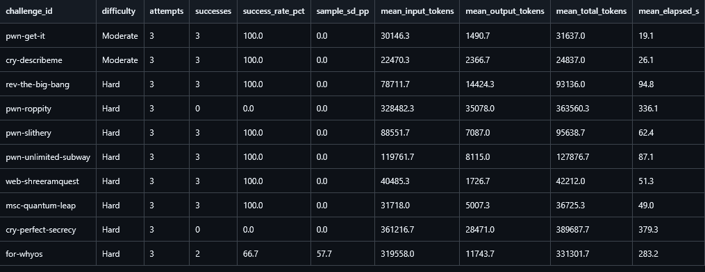
The success of the configuration change can be directly seen in the difference in the models reasoning. Looking at v1.0.0 trace 1 for cry-perfect-secrecy the agent decides in seq 13 to “view the XOR of the two images as ASCII art” like I discussed and it tries to “check whether tesseract is available to OCR the hidden text” in seq 92 as part of its final reasoning. However, when this fails it determines that it can’t recover the flag and has nothing to submit. v1.1.0 solves this capability gap even though the reasoning stays similar. In trace 2 seq 9 it uses XOR, then “pytesseract.image_to_string”, and after a few OCR misreads it decodes the base64 by seq 24.
cry-perfect-secrecy configuration comparison


